School of Life Science, Engineering & Design

Course title | Project system | Examination code: | T.LED.43316
Phase of study | Propedeuse | EC | 7
Lecturer in charge : | Christiaen Slot / Evert Berendsen | Document Version: | 2015 spring

Course description / Moduul omschrijving
The aim of this module is to learn, in a group, more about project management and basic technical calculations, simulations and measurement. This module is done as group work. The group acts as a real engineering company. The group or engineering company assignment is ”Saxion EEE is looking for an engineering company who can modify a simple coffee maker machine into an advanced coffee-maker-machine. The temperature of the drinking coffee should be adjustable.”

Course objectives / Doelstellingen
Students will be able to:
- Analyse an existing coffee-maker-machine
- Calculate and build temperature control
- Work for a customer
- Work in a structured way following the V-model
- Experience teamwork
- Organise meetings
- Feel time pressure
- Report technical information
- Present all project results in the oral way, via a poster and with a demonstration

Course topics / Onderwerpen
- 40% Technical Temperature-measurements-control:
- 60% Project management:

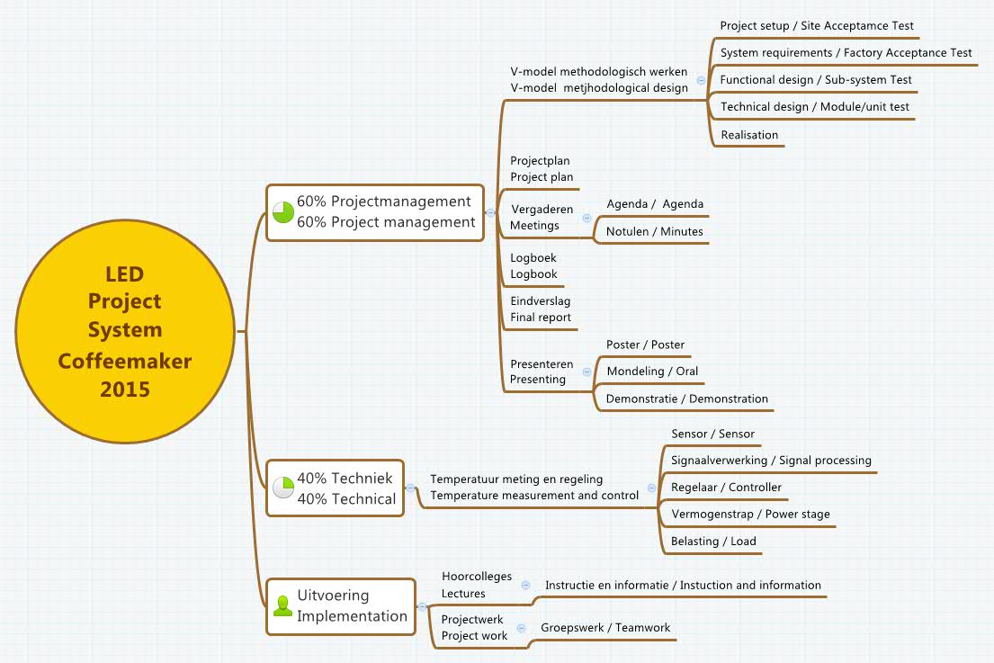

Prerequisites / Voorkenniseisen
Mathematics and Physics on college level

Literature / Literatuur

Title | Author | Publisher | ISBN
Course book coffee maker | J.W.Bollen
Project management | Roel Grit | Noordhof uitgevers | NL 978-90-01-79093-6  ENG 978-90-01-79092-9

Educational materials required / Benodigde onderwijsmiddelen
- Hardware took box
- Internet access
- Simulation program
- Complete office 2010 program

Competences / competenties

The competences are the eight competences of a Bachelor of Engineering.
 | Competence | Level (*)
1 | Analyse | 1 | - Translation of user requirements into a methodological approach  - Analysis for the Design Requirements  - Analysis for the Functional Design and motivation of choices  - Analysis for the Technical Design and motivation of choices
2 | Design/Engineer | 1 | Technical execution of the project
3 | Realise | 1 | Building of the system (usable for a demonstration)
4 | Control | 1 | Verification and Validation of the system  (Testing, part of the report)
5 | Manage | 1 | - Management during the execution of the project  (following the methodological approach in the PP)  - Modification of the PP according to changing situations
6 | Advise | 1 | - Recommendations for future development (part of the report)
7 | Research | 1 | - Research and analysis for the Design Requirements  - Research for the Functional Design and motivation of choices  - Research for the Technical Design and motivation of choices
8 | Professionalise | 1 | - Communication  - Collaboration  - Attitude  - Presentation
(*) Level
1 Nature of the assignment: basic, structured, applying a standard methodology
Nature of the context: known, basic, mono discipline, at the university
Amount of independency: limited, controlled guidance

Assessment / Toetsing

A group report of the whole process of innovating the coffee-maker is made by each group. Also a final presentation will be done by the whole group, each member participating. At the end a demonstration of the modified coffee-maker is done. It should work correctly!

Project Assessment
Assessment (*) | Analyse | Design/Engineer | Realise | Control | Manage | Advise | Research | Professionalise | Who | Result | Weighing
Project Plan | x |  |  |  | x |  |  |  | Group | mark | 10%
Technical Functioning | x | x | x |  |  |  | x |  | Individual | mark | 10%
Professional Functioning |  |  |  |  | x |  |  | x | Individual | mark | 20%
Result |  |  |  | x |  |  |  |  | Group | mark | 20%
Reports | x | x |  |  |  | x | x | x | Group | mark | 30%
Presentations |  |  |  |  |  |  |  | x | Individual | mark | 10%
(*) See for a more detailed description the assessment form of the project.

Beside the project all students get classes in designing a Printed Circuit Board PCB in the hardware lab.
PCB design will be explained and every students should make his/her own PCB.

The totally mark of this module consist of 2 items:

Project mark 1 …. 10
PCB mark PASS / FAIL

In total this module gives you 7 ECTS when passed

Lesson schedule / lessen planning
Students have instruction colleges, will work as a group in the lab, and organise meetings

Wk: | Method | Time | topics | Literature
3.1 | - instruction  ========  - project work |  | - Introduction to the assignment / user requirements / client contact / Acceptance test plan / V-model (in general) / time activities / explain logbook / deliverables / review  ============================  - Making the groups / making companies / logo design / different roles / starting logbook making the company | Project management  Roel Grit
3.2 | - instruction  ========  -project work |  | - Wheatstone bridge theory / temperature sensor  ============================  - Wheatstone simulation (individual) / show format for a measurement report / make measurement report  - Discuss simulation results per group / class
3.3 | - instruction  ========  -project work |  | - V model / Project setup / System requirement (general) / Functional design (general) Technical design (general) / Realization (general)  ============================  - Analyze original machine / describe working of the machine in 3 domains: electrical chemical and thermally. Describe components draw electrical circuit (Multisim) and give electric circuit in detail. | Multisim
3.4. | - instruction  ========  - project work  ========  -meeting 1 |  | - Blok diagram temperature control, system requirements (in detail)  ============================  - Temperature measurements 12 Volt  - Temperature measurements 15 Volt  - Processing measurement data in EXCEL  ============================  - agenda 1  - (original machine, functions components, electrical circuit, project plan, logbook pp)
3.5 | - instruction  ========  - project work  ========  -meeting 2 |  | - Concepts, morphological diagram, choosing concepts, functional requirements (in detail)  ============================  - Brainstorm functional design / Who is the user / What is the new temperature range / What concept is chosen in connection to knowledge (complexity) / What functionality will the new machine have.  ============================  Agenda 2 / minutes meeting 1  (Analyse temperature data / Conclusions / New temperature range / Functional design)
3.6 | - instruction  ========  - project work |  | - Pilot concept presentation per group by chairman.  ===========================  - Implementing feedback / Work out new ideas / Start documentation / start presentation
3.7. | - instruction  ========  - project work |  | - Reporting in detail / poster presentation in detail / Data on cost calculations  ============================  - Finalise documentation  - Hand in minutes 2
3.8. | - project work |  | - Hand in analyse report  - Work on ppt for functional design presentation
3.9
3.10 | - presentation |  | presentation functional design GO/ NO GO
4.1 | - project work  -meeting 3 |  | - Technical design / technical block diagram –calculating and selecting essential components – 3D and 2D mechanical design – schematics and PCB design – Pseudo code – module / unit test plan  - ============================  - Agenda 3  - Progress
4.2 | - project work |  | - Technical design / technical block diagram –calculating and selecting essential components – 3D and 2D mechanical design – schematics and PCB design – Pseudo code – module / unit test plan
4.3 | - project work  ========  -meeting 4 |  | - Realisation / mechanical – making components and module assembly / Electrical-Electronic – making PCBs and module assembly / Software – module coding  ============================  Agenda 4 / minutes meeting 3
4.4 | - project work |  | - Realisation / mechanical – making components and module assembly / Electrical-Electronic – making PCBs and module assembly / Software – module coding  Module/unit test – Sub-system test – Factory Acceptance test
4.5 | - project work |  | - Measurement
4.6 | - project work  ========  -meeting 5 |  | - Demonstration of working machine – Site acceptance test  - Finalize report / Work on poster / Work on PPT / Finalize logbook  ===========================  Agenda 5 / minutes meeting 4  - Last meeting: what to do to finalise everything
4.7 | - project work |  | - Hand in final report
4.8. | - presentation |  | Final presentation - Inclusive demonstration  Poster presentation  Side acceptance test  - THE END

